How to handle alerts/pop-up

First screenshot explains on how to get text, and accept or dismiss alert.

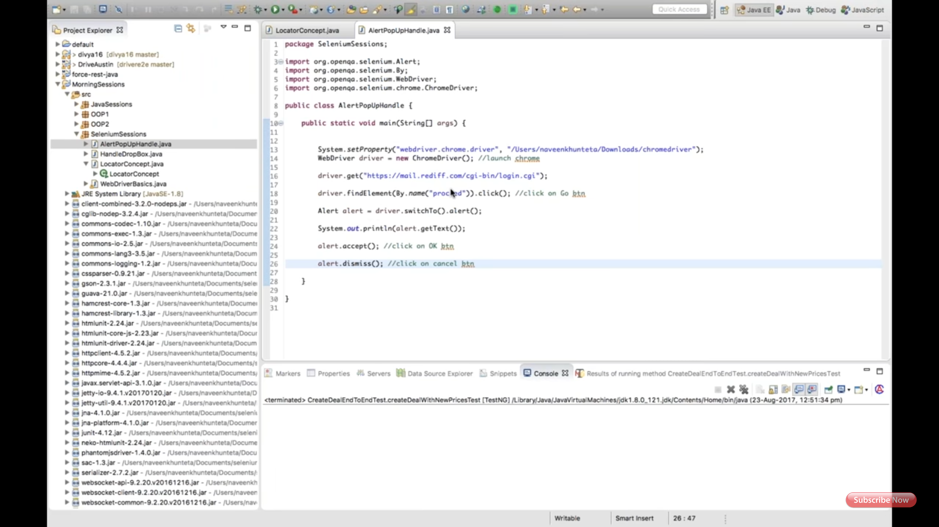

Second screenshot explains on how to handle file upload by using sendKeys()

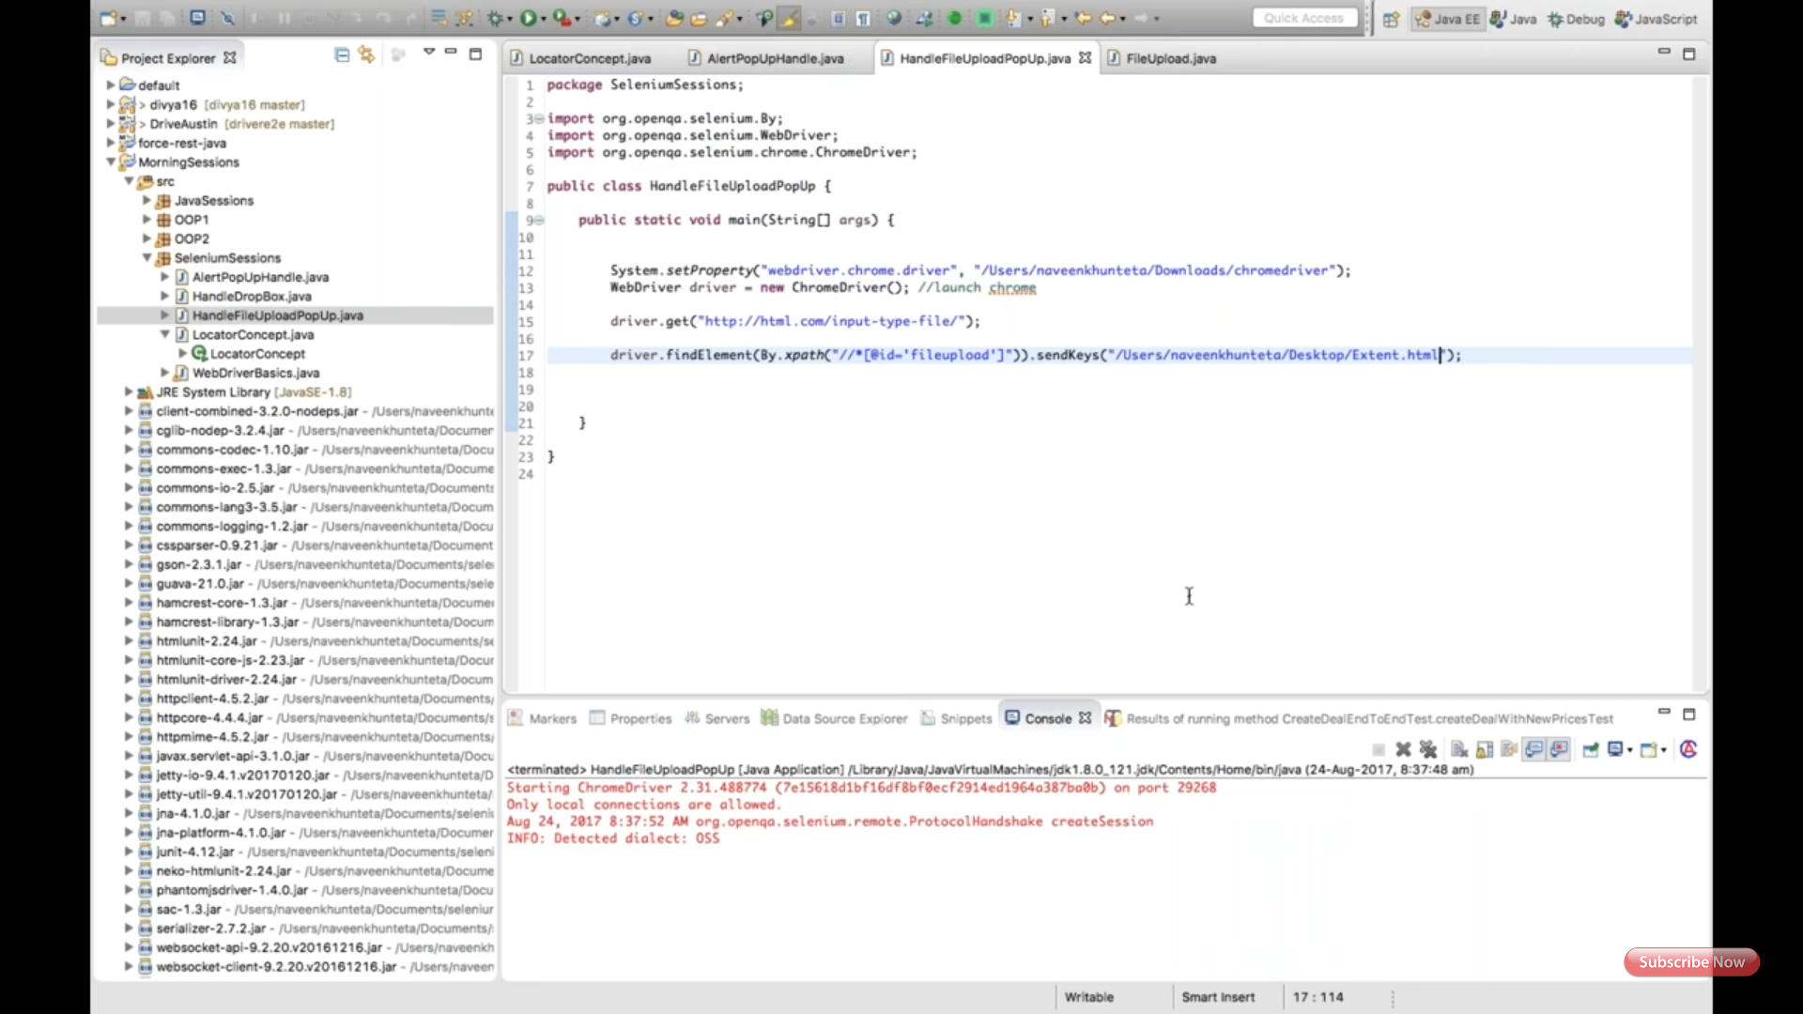

Third screenshot showing how the browse/upload, it should have type = 'file' in html section, to use with the sendKeys().

